SRS Document for Inventory Management System

DBMS Project

**Software Requirements Specification (SRS) Document**

**Inventory Management System (IMS)**

**1. Introduction**

**1.1 Purpose**

The purpose of this document is to outline the functional and non-functional requirements of the **Inventory Management System (IMS)**. This system aims to automate inventory tracking, simplify product, customer, and employee management, and improve overall business efficiency.

**1.2 Scope**

The IMS will:

* Digitize inventory processes to reduce manual errors.
* Provide modules for **Employee, Product, Category, Customer, Order, Ledger, and Invoice Management**.
* Allow secure access and logout functionality.

**1.3 Intended Audience**

* **Developers** (Muhammad Hasnain, Saleem Ahmed, Kelash)
* **Stakeholders** (Business owners, Inventory managers, Employees)
* **End Users** (Store managers, Sales staff, Accountants)

**1.4 Technologies Used**

* **Frontend**: Java GUI (AWT + Swing)
* **Backend**: MySQL
* **Programming Language**: Java

**2. Overall Description**

**2.1 Product Perspective**

The IMS is a standalone desktop application that interacts with a MySQL database to manage inventory, sales, and customer data.

**2.2 User Classes**

| **User Role** | **Permissions** |
| --- | --- |
| **Admin** | Full access (Add/Delete Employees, Products, Categories, Generate Invoices) |
| **Employee** | Limited access (View Products, Process Orders, Update Inventory) |
| **Customer** | View products, place orders |

**2.3 Operating Environment**

* **OS**: Windows, Linux, macOS
* **Database**: MySQL
* **Java Runtime Environment (JRE)**: Required

**3. System Features & Requirements**

**3.1 Functional Requirements**

| **Features** | **Description** |
| --- | --- |
| **Employee Management** | Add, view, update, and delete employee records. |
| **Product Management** | Add, update, and delete products; track stock levels. |
| **Category Management** | Add and delete product categories. |
| **Customer Management** | Store and manage customer details. |
| **Order Management** | Record and track customer orders. |
| **Ledger Management** | Track customer transactions and payments. |
| **Invoice Generation** | Generate and print sale invoices. |
| **Login/Logout System** | Secure authentication for users. |

**3.2 Non-Functional Requirements**

| **Requirement** | **Description** |
| --- | --- |
| **Performance** | System should handle 100+ concurrent users with <2s response time. |
| **Security** | Password-protected login; role-based access control. |
| **Usability** | Intuitive GUI with minimal training required. |
| **Reliability** | 99% uptime; automated backups. |

**4. External Interface Requirements**

**4.1 User Interface (UI)**

* **Dashboard**: Displays inventory summary, pending orders.
* **Forms**: Input fields for adding employees, products, customers.
* **Reports**: Sales, inventory levels, and ledger summaries.

**4.2 Hardware & Software Requirements**

* **Minimum RAM**: 4GB
* **Storage**: 500MB (for database and application)
* **Database**: MySQL 5.7+

**5. System Models**

**5.1 Use Case Diagram**

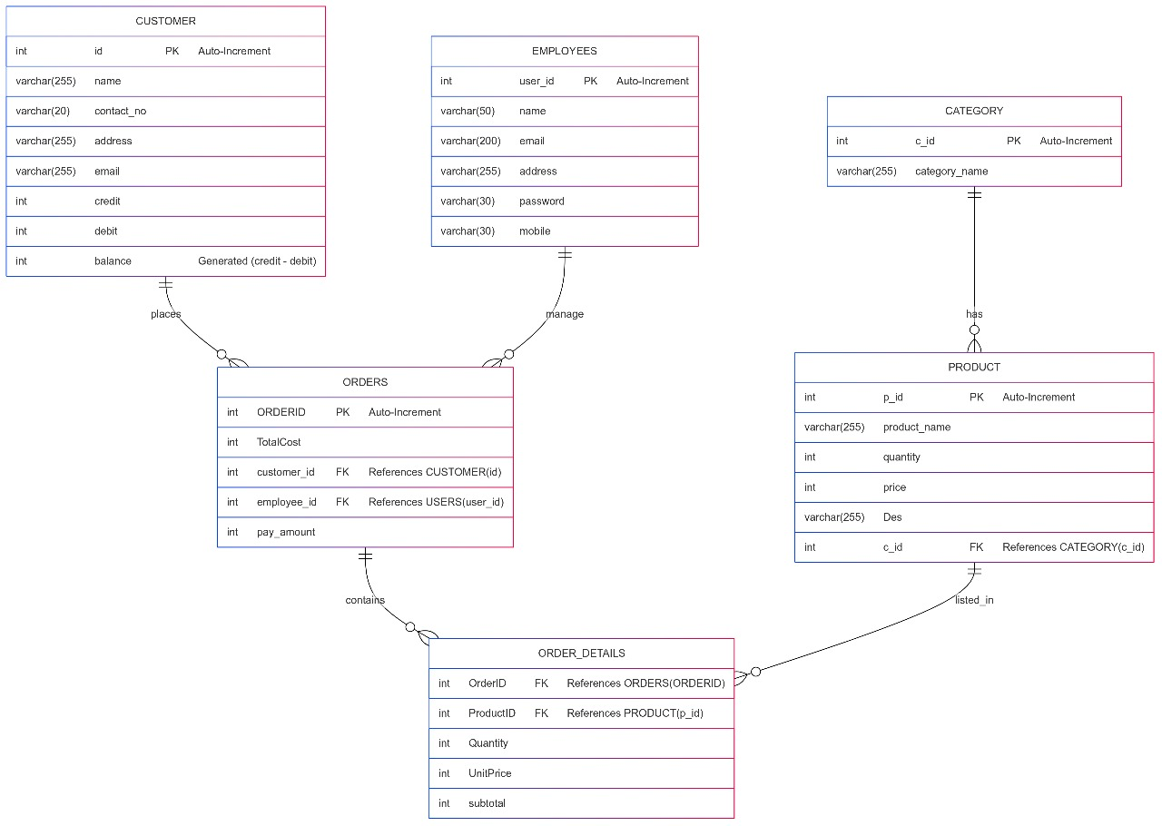**5.2 ER Diagram**

*(An Entity-Relationship diagram depicting tables: Employees, Products, Categories, Customers, Orders, Invoices.)*

**6. Conclusion**

The **Inventory Management System** will streamline business operations by automating inventory tracking, reducing errors, and improving workflow efficiency. The system will be developed using **Java (AWT/Swing)** for the frontend and **MySQL** for the backend.

**Prepared by**: